[**The Cash Flow statement**](https://zerodha.com/varsity/chapter/cash-flow-statement/)

The Cash flow statement is a very important financial statement, as it reveals how much cash the company is actually generating.

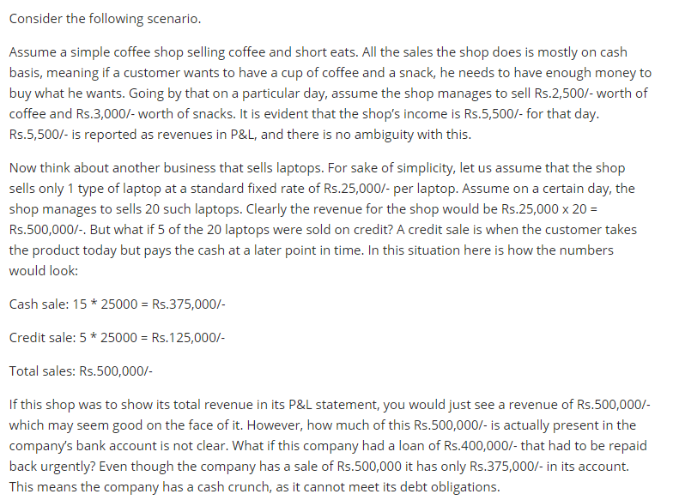

**To sum up, every company’s financial performance is not so much dependent on the profits earned during a period, but more realistically on liquidity or cash flows**.

## **Activities of a company**



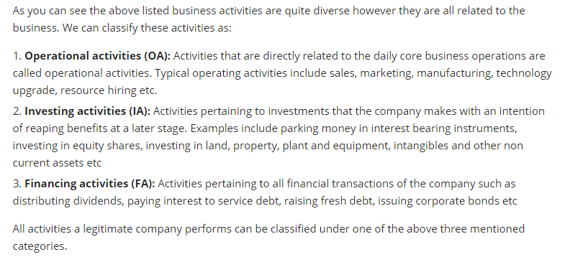



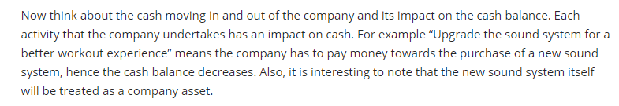

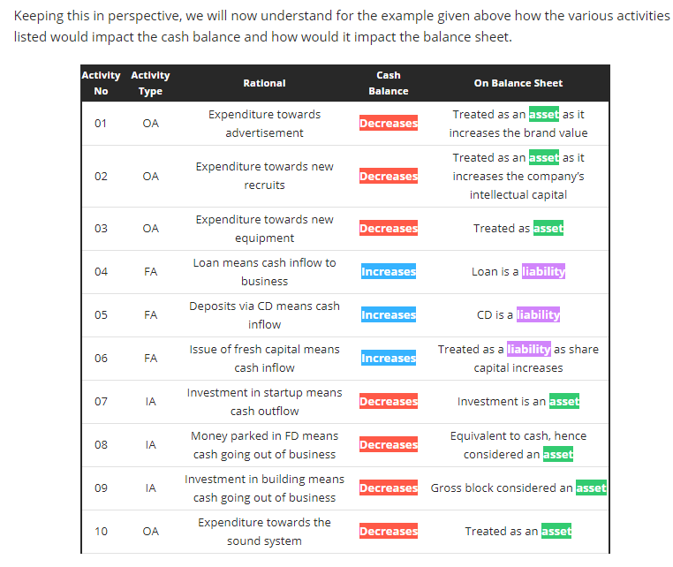

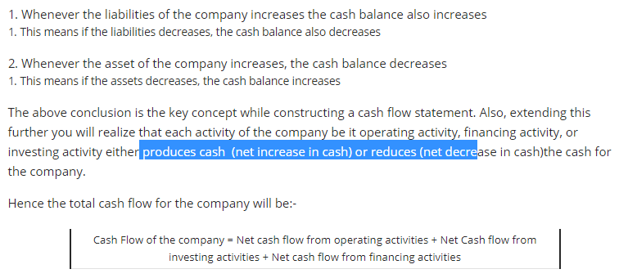

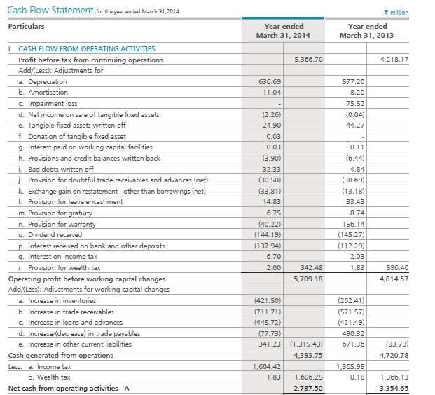

ARBL has generated Rs.278.7 Crs from operating activities. Note, **a company which has a positive cash flow from operating activities is always a sign of financial well being.**

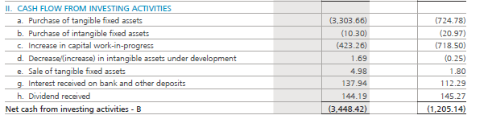

ARBL has consumed Rs.344.8 Crs in its investing activities. **This is quite intuitive as investing activities tend to consume cash.** Also remember healthy investing activities foretells the investor that the company is serious about its business expansion. Of course how much is considered healthy and how much is not, we need to find out.

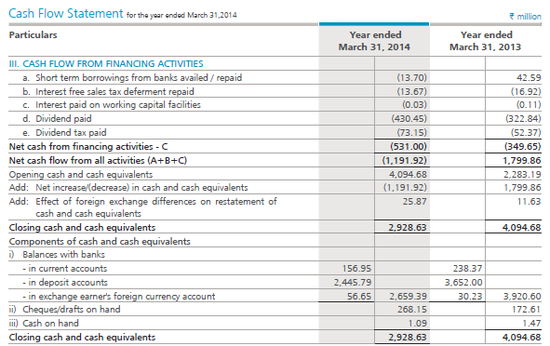

ARBL consumed Rs.53.1Crs through its financing activities. If you notice the bulk of the money went in paying dividends. **Also, if ARBL takes on new debt in future it would lead to an increase in the cash balance** (remember increase in liabilities, increases cash balance). We know from the balance sheet that ARBL did not undertake any new debt.

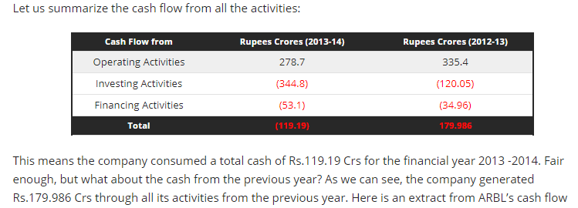

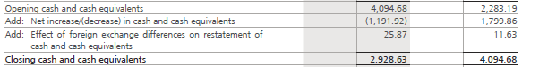

It says the opening balance for the year is Rs.409.46Crs. How did they get this? Well, this happens to be the closing balance for the previous year (refer to the arrow marks). Add to this the current year’s cash equivalents which is (Rs.119.19) Crs along with a minor forex exchange difference of Rs.2.58 Crs we get the total cash position of the company which is Rs.292.86 Crs. This means, while the company guzzled cash on a yearly basis, they still have adequate cash, thanks to the carry forward from the previous year.

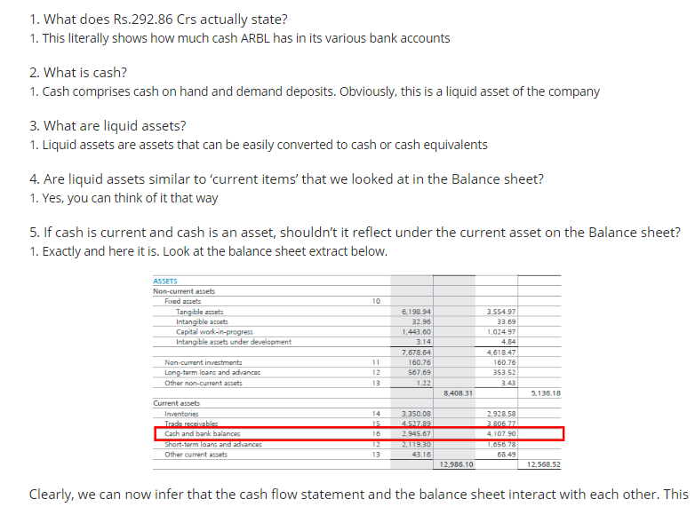

## **A brief on the financial statements**

